Uncovering thousands of endosymbiont DNA transfer events within single cockroach genomes

Authors: Kyle M. Ewart*, Maxim Adams*, Zhuzhi Zhang*, Louise Baker, Kokuto Fujiwara, Yoshinobu Hayashi, Leo Featherstone, Oscar Lo Lu, Jil Helbling, Maya Moral, Kiyoto Maekawa, Harley Rose, Aaron Jex, Simon Ho, Nathan Lo

*These authors contributed equally

Current Biology Report structure
Reports present findings of broad biological interest in a concise, to-the-point style. Reports are typically limited to six journal pages (usually around 2,500 words of main text, i.e., all of the text in the manuscript except for the summary, the STAR Methods text, any supplemental information text, and references section), and there should be no more than four display items (figures and tables). Additional items and details may be published online as supplemental information

Summary (needs to be <250 words)
Horizontal gene transfer (HGT) challenges conventional Darwinian evolutionary models by introducing genetic material across species boundaries. Research on HGT in eukaryotes has focussed on transfers of coding sequences (Villa & Viñas, 2019; Li et al., 2022); insertions resulting in non-coding DNA remain poorly understood. We investigated horizontally transferred DNA in the genomes of 14 cockroach taxa, including 8 genomes newly sequenced using long read technology, and 4 termite species. We focussed on transferred DNA inserts ≥50 bp from the obligate endosymbiont Blattabacterium cuenoti (hereafter Blattabacterium). Previous studies of eukaryotes harbouring long-term endosymbionts have found little or no evidence for horizontal transfers from these symbionts. However, we found that cockroach genomes harboured between 101 and 4955 horizontal DNA transfers from Blattabacterium in their genomes. Some inserts appear to have persisted for >28.7 million years in panesthiine burrowing cockroaches. We identified numerous novel chimeric inserts comprising up to eight short segments from disparate locations in the Blattabacterium genome. RNAseq data from three species indicated that 5.04–8.58% of the inserts are transcribed in whole insect preparations, the majority of which (3.38-6.30% of all inserts) was from intergenic regions. The 4955 inserts found in Macropanesthia lithgowae exceed by >29 times the number of inserts (170) previously reported from any eukaryotic species, with the exception of rotifers. This level of DNA transfer is correlated to that of the transfers from the mitochondrial genome, an ancient bacterial endosymbiont turned organelle, highlighting the intimate relationship between endosymbiont and host genomes.

Results

Cockroach genomes contain thousands of Blattabacterium-derived inserts

We explored the prevalence, distribution and characteristics of DNA inserts in the genomes of cockroaches and termites that originated from the symbiont Blattabacterium. This symbiont is found in specialised cells of cockroach fat-bodies, and is inherited maternally though the eggs (Sacchi et al., 1988), providing the potential for recurrent transfer events. Blattabacterium infected the ancestors of cockroaches >150-200 Mya (Lo et al. 2003; Bourguignon et al. 2018), and is present in almost all lineages, but was lost from all termites with the exception of Mastotermes darwiniensis. Although long-term obligate endosymbionts such as Blattabacterium are thought to contribute no or few DNA transfers from their genomes to host genomes, previous studies have only focussed on the transfer of protein-coding sequences (Nikoh et al. 2010; Husnik et al. 2013; Luan et al. 2015; Sloan et al. 2014; Liu et al 2025).

To locate all possible DNA transfers from Blattabacterium to host genomes, we first created a library comprising 77 Blattabacterium genomes (Table S1), each of which was broken into 150-bp fragments. We then aligned these short Blattabacterium fragments to 23 genomes representing 14 cockroach and 4 termite species (multiple genome versions were used for some species) to characterise putative inserts with a minimum length of 50 bp. To identify unique insert events within a genome, we excluded inserts likely arising from duplication or transposition (based on the sequence similarity of inserts within a genome).

Using this novel approach, we characterised a remarkable 40,484 unique Blattabacterium-derived inserts across the cockroach genomes (93-4900 per genome; Fig. 1A), ranging in size from 50-5743 bp, with a median size of 161 bp (Fig. 1B). Most of the genomes in which we detected large numbers (i.e. several thousand) of Blattabacterium inserts were sequenced using ONT long-read technology, with N50s of 860-5330 kb, and 95.2-99.5% complete BUSCOs (Table S2). Most inserts (#%) were found within long reads, flanked on both sides by cockroach host sequence. Further, the long-read sequencing depth of these insert regions was typically >#, indicating that the Blattabacterium and cockroach flanking DNA was not a result of artefactual chimeric reads. We carried out a number of additional analyses to confirm that the identified inserts were ‘true’ transfers from Blattabacterium to host, rather than assembly artefacts, or derived directly from Blattabacterium DNA. These included the removal of inserts arising from false assembly duplications, highly repetitive or low-complexity regions, and long regions aligning with bacterial DNA that may have been derived from genuine Blattabacterium sequence reads. Finally, manual inspection of BLAST results from inserts of each genome confirmed that they: 1) had been transferred from Blattabacterium and not other related Bacteriodales; and 2) were not the result of assembly errors.

Evolution of Blattabacterium-derived inserts in cockroach genomes

Inserts in host genomic DNA were found to originate from across the entire Blattabacterium genome, which is highly conserved in size, gene content and order across cockroach species (Fig. 1C). There was no apparent bias in the origin of inserts with respect to their position in the Blattabacterium genome. In the five cockroach species with the highest number of inserts (>4000), the total amount of inserted DNA ranged from 687-1014 kb, representing 0.05-0.06% of total cockroach genome length. An examination of insert position across all species revealed that 15.38–25.56% were found in intragenic regions, and 74.44–84.62% were found in intergenic regions (excluding termites due to the sparsity of their annotations). This differs from the proportion of genic regions in our assembled cockroach genomes, which was > 25% in all but four genomes (range 13.79–33.71%). The average size of inserts (+/- standard deviation) in each of these regions was 199.13 (+/- 138.75) bp, and 191.70 (+/- 126.24) bp, which was significantly higher for the genic inserts (one-way nested analysis of variance: F_{1,39424} = 17.96, p < 0.01). The insert sequences comprised a comparable GC content (17.9-29.6%) to the Blattabacterium genomes (21.3-28.2%), and considerably lower than the GC content of the cockroach and termite genomes (34.5-41.1%).

Closely related cockroach taxa were found to have similar numbers of inserts, suggesting that many of the inserts had been inherited in a vertical fashion (Fig. 1A). We inferred a minimum ‘age of transfer’ for each insert by calculating their similarity to inserts in other species. If an insert shared higher sequence identity with inserts in other cockroach species than to the Blattabacterium genome harboured by its host, this suggested the insert was transferred in an ancestor of these species (Fig. 2A). On the other hand, inserts that displayed the highest identity with Blattabacterium genomes of their hosts were inferred to have been transferred after diverging from the other species included in the analysis. We confirmed the homology of X putatively ancestral inserts, and thereby their common origin, by inspecting 5 kb of cockroach genome sequence upstream and downstream from the insert position across multiple taxa (Fig. 2B). For all examined inserts, although multiple taxa harboured homologous DNA across these ~10 kb regions, some species were inferred to have subsequently lost the inserts. Using this approach, and considering only inserts in homologous regions, we inferred that the oldest inserts were transferred into the ancestor of all panesthiine and geoscapheine species, which is estimated to have existed at least ~28.7 Mya (Beasley-Hall et al., 2021). There was also one potentially ancient Blattabacterium insert in the Z. nevadensis genome (Fig. 1A); however, we were unable to confidently verify its authenticity with our methods, and requires further study. We also examined pairwise nucleotide divergence within inserts and in equivalently sized segments 5 Kb upstream and downstream of X inserts. Divergence within inserts was/was not found to be significantly lower than adjacent regions, providing no/potential evidence of insert function.

Transcription and chimeric nature of inserts

We used RNAseq data to investigate the transcription of inserts in Panesthia t. tegminifera (Z011), Macropanesthia lithgowae (Z009), and Panesthia sloanei (Z001). By mapping insert sequences to RNA contigs using BLASTn, we found that 91.42–94.96% of inserts showed no evidence of transcription. Of the remaining inserts, which were observed in assembled RNA contigs, 26.59–32.97% overlapped with annotated genic regions of the cockroach genome (1.66–2.28% of total inserts; 3.38–6.30% of total inserts were transcribed and mapped to intergenic regions). A small fraction (0.40–0.65%) of inserts mapped to exon sequences within mRNA sequences.

During manual BLAST inspections, we noted that several inserts displayed a chimeric nature, comprising Blattabacterium-like sequences of length X-Y bp from distant areas within the Blattabacterium genome placed directly adjacent to each other (Fig. S3). Such chimeric DNA inserts were present in all cockroach genomes, sequenced by separate research groups using different sequencing technologies. A maximum of eight Blattabacterium-derived segments from distant genomic regions were found directly adjacent to each other. We mapped four chimeric inserts against transcriptome data for M. lithgowae and P. tryoni tegminifera and found that none of these were clearly transcribed, however two had partial matches with mRNA contigs (Fig. Y).

Discussion

The number of HGTs that eventually become fixed in a species is expected to represent only a small fraction of the actual number of acquisition events that occur across evolutionary time (Van Etten & Bhattacharya, 2020). While there is an abundant body of research focused on insertions with homology to protein-coding sequence, transfers that result in sequences that do not encode proteins, or that result in sequences of unknown function, have been largely ignored. Such insertions nevertheless introduce abrupt genetic variation, which may persist in the genome if these insertions have minimal or no fitness effects, if purifying selection is insufficient, or if they acquire functional roles such as regulation of gene expression (Husnik & McCutcheon, 2018).

With the exception of rotifers, which have an unusually high number of transfers associated with anhydrobiosis (Simion et al 2021), the highest number of transfers reported in any animal was previously 170, in the whitefly Bemisia tabaci (Li et al 2022). There are a number of reasons why we may have identified >25 times this number in the cockroaches we examined. First, we analyzed both genic and non-genic regions of the genome. Second, while previous studies have filtered for the completeness of inserted coding sequences, we identified inserts as short as 50 bp. Relatively short sequences were indeed the most prevalent type of insertion (median length = 161 bp). Third, previous studies often relied on short-read sequencing, where inserts spanning the majority or entirety of a sequence read may have been misidentified as bacterial contamination and discarded during genome assembly. In contrast, we used long-read sequencing for most Panesthiinae genomes, which enabled us to confirm the presence of these inserts within single sequence reads. We found differing numbers of inserts in the separately published genomes of each of the pests Periplaneta americana (101-658) and Blattella germanica (278-285), possibly due to the use of short read versus long read sequencing technology in each case.
Fourth, we focussed on horizontally transferred DNA segments from Blattabacterium, an obligate and maternally transmitted endosymbiont whose genome is likely to come in close contact with host nuclear DNA during egg formation and zygote development. Previous studies of HGT from long-term obligate endosymbiotic bacteria to the genomes of their insect hosts have generally recorded very few or no such transfers (Nikoh et al. 2010; Husnik et al. 2013; Luan et al. 2015; Sloan et al. 2014). This has been attributed to the lack of mobile genetic DNA present in these genomes, as well as a lack of proteins associated with HGT encoded in their genomes (Liu et al., 2025). A recent study of HGT in two cockroach and 45 termite species did not detect any horizontal transfers from Blattabacterium in either of the two cockroaches examined (Cryptocercus meridianus and Blatta orientalis), or the termite Mastotermes darwiniensis, all three of which harbour this symbiont (Liu et al., 2025). However, this lack of detection of transferred DNA of symbiont origin is likely due to a focus on protein coding sequence. We expect that the use of the approaches described in our study will result in increased detection of endosymbiont-derived inserts in the genomes of eukaryote hosts.
Panesthiine taxa were found to possess substantially higher numbers of Blattabacterium-derived inserts (Fig. 1A). These are known to have long generation times relative to most Blattodea (reference?), which might be expected to reduce opportunities for transfer per unit time, if transfer occurs only during oogenesis. However, it is unknown whether and how other components of Blattabacterium life history, including population load across cockroach species and rates of cell division, influence the prevalence of transfers. Microscopic analyses of Blattabacterium in host tissues have revealed high rates of cell division, in addition to frequent asymmetric cell division, compared with other insect symbionts (Noda et al., 2024). Alternatively, we previously found that Panesthiinae exhibit considerably more genome-wide relaxed selection compared to other cockroaches, including those examined here (Ewart et al., 2024). Insufficient purifying selection could possibly allow larger numbers of inserts to persist in Panesthiinae genomes, under the assumption that most inserts have neutral or slightly deleterious impacts on fitness (reference). The function of Blattabacterium-derived DNA inserts in cockroach genomes remains unclear, however the persistence of ancestral inserts in the Panesthiinae, inferred to have been transferred <= 28.7 Mya, may be suggestive of a functional role. Further, we detected a number of inserts which appear to have taken on a role as exons within putative protein coding genes.
The widespread occurrence of horizontally transferred DNA in cockroach genomes resembles the well-established phenomenon of mitochondrial DNA transpositions into the nuclear genome (i.e. numts; Pamilo et al., 2007; Uvizl et al., 2024; Keeling, 2024). We repeated our analyses using 150-bp fragments of cockroach and termite mitochondrial genomes, and detected numt inserts in each genome, ranging in number from 22-1095 (termites 22-150; cockroaches 695-1095; Supplementary Table X). The number of Blattabacterium-derived inserts was found to be significantly correlated with the number of mitochondrial-derived inserts (Spearman’s correlation, p = 2.6 x 10⁻⁵). The occurrence of numts is understood to be regulated through primarily netural processes, which may further implicate relaxed selection as a key factor regulating the tempo of insertion and persistence of exogenous DNA in the genome.
Our discovery of chimeric insertions comprising sequences from diverse parts of the Blattabacterium genome (e.g. see Fig. S3) is akin to previous reports of chimeric numts in Aradiopsis thaliana (Fields et al., 2022). These chimeras are likely produced by non-homologous end joining repair that incorporate segments of Blattabacterium DNA that possibly arise following symbiont cell replication or death. Chimeric genes have previously been described in other species, although at a broader scale than the chimeric inserts we have identified in cockroaches (Rogers et al., 2012). In Drosophila, chimeric genes resulted from retrotransposition and the combination of exons and introns from two ‘parental’ genes (Long and Langley, 1993; Rogers et al 2009). The chimeric genes believed to have arisen in the ancestor of eukaryotes (Méheurst et al., 2018) are hypothesised to have come about as a result of intron invasion and combination of domains that allowed novel functions.
Our findings suggest that horizontal transfer of DNA from prokaryote symbionts to eukaryotes may be considerably more pervasive than previously thought. Furthermore, the persistence of numerous inserts over millions of years indicates that they may have assumed functional roles in both genes and intergenic regions, are effectively neutral, or are deleterious yet maintained under relatively weak purifying selection. Future research on cockroaches and other species harbouring obligate endosymbiotic prokaryotes will assist with uncovering the potential functional effects of inserts, providing a more comprehensive understanding of how horizontal transfer shapes genome evolution.

Acknowledgments

We thank James Walker, and Bruce Gray for assistance with sample provision for genome sequencing, Jack Marsden for technical assistance, Pawsey Supercomputing Research Centre, and Australian Biocommons Leadership Share (ABLeS) for providing access to Australia’s National Computational Infrastructure. This study was supported by grants from the Australian Research Council (FT160100463; DP220103265), and The University of Sydney (Partner Collaboration Awards).

Figures

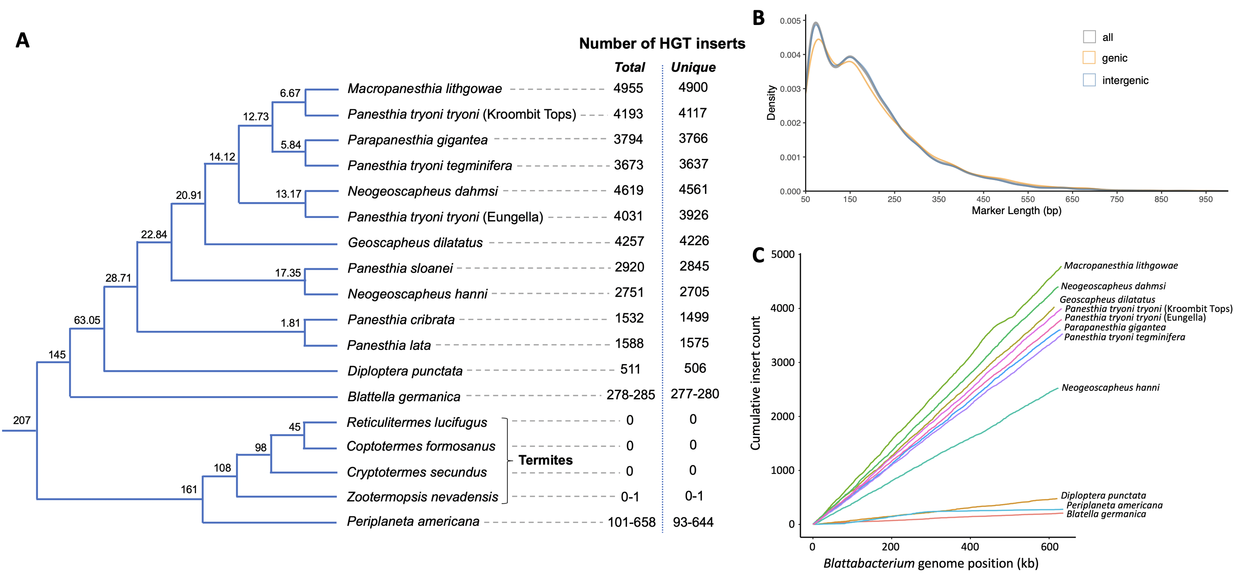
Figure 1. Cladogram of taxa analysed in this study alongside the total number of HGT inserts within each genome, and the number of unique inserts (after excluding inserts likely arising from duplication or transposition) (A). A range of insert numbers are listed for species in which multiple genomes were analysed. The tree is not to scale; node ages (Mya) are based on previous studies (Evangelista et al., 2019; Beasley-Hall et al., 2021; Adams et al., 2024). The length distribution of inserts (B). One genome per species was analysed (the genome version with the most number of inserts). Only lengths >50 bp are depicted, as this was the minimum length threshold, and the plot removed insert >1000 bp for clarity (51 of the 39,411 markers have been excluded). C = Placeholder for a depiction of the Blattabacterium genome, with the distribution of where the inserts derive from – hopefully Leo will provide this. One genome per species was analysed (the genome version with the most number of inserts), and only species with their associated species specific Blatta genome published … (Table S#)

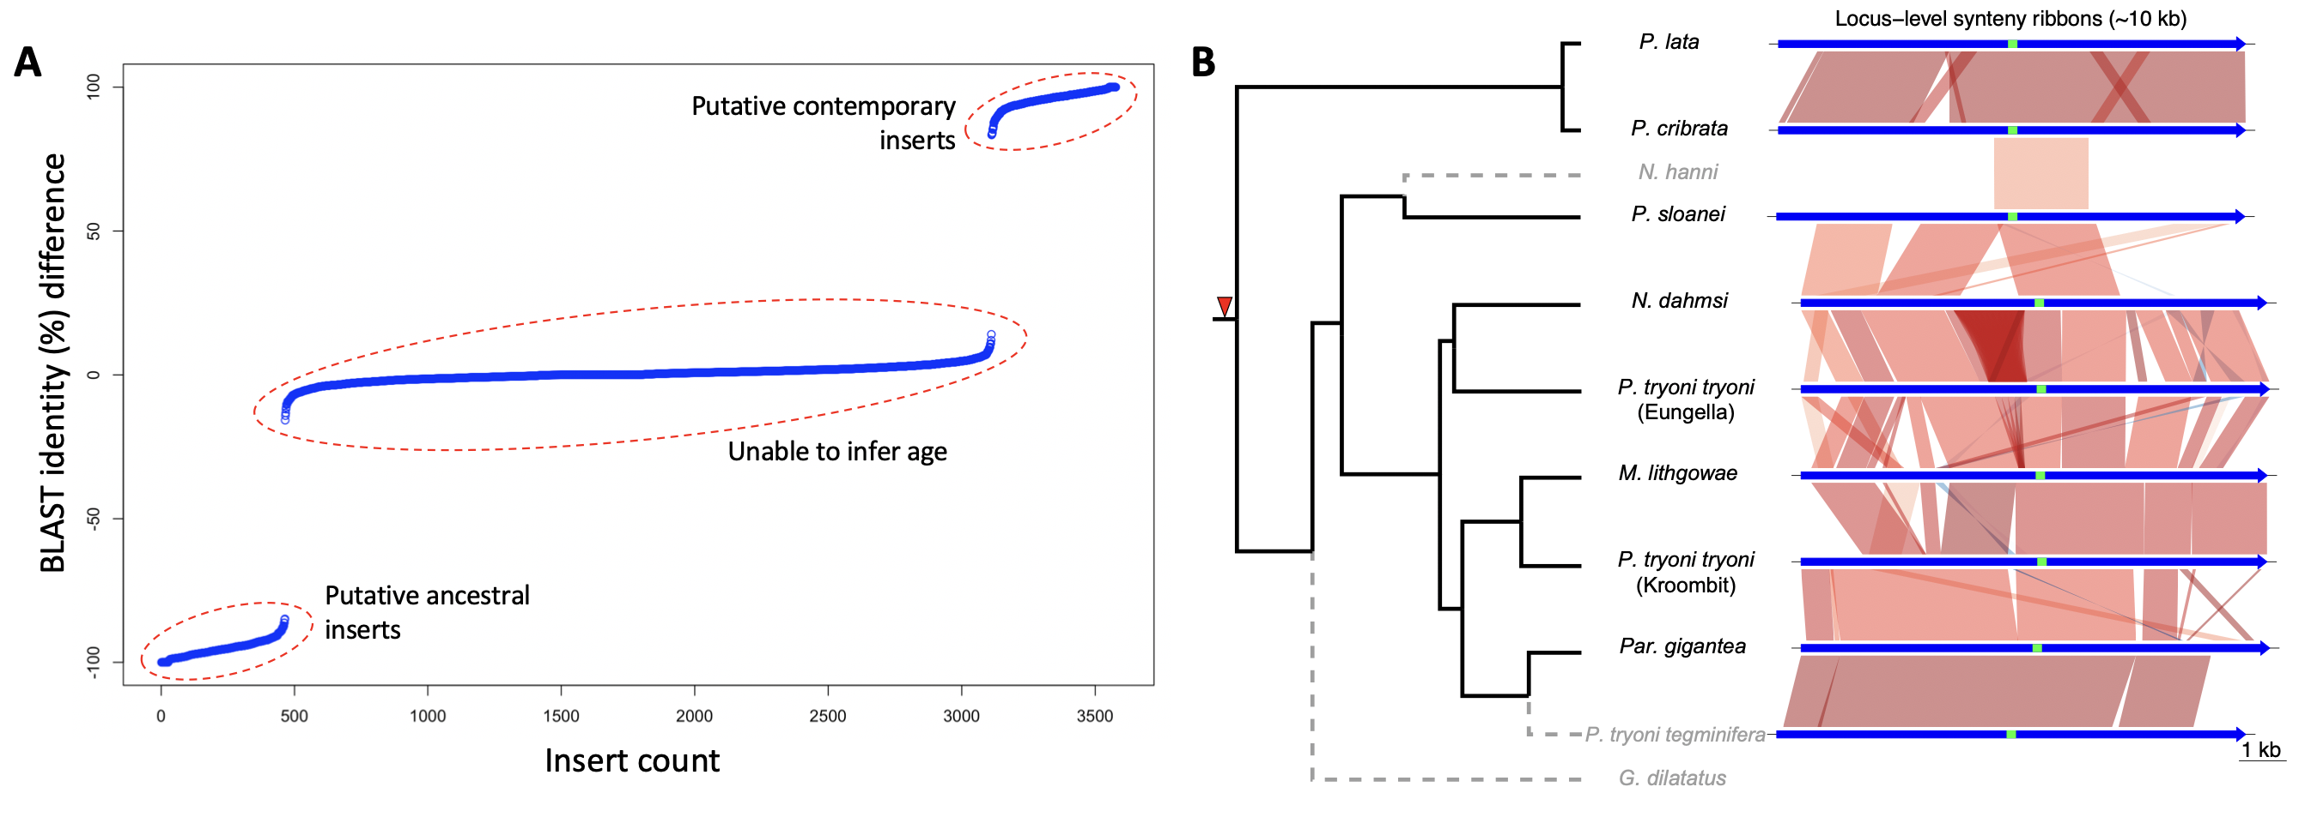
Figure 2. Example of identifying potentially ancestral inserts by comparing the top BLAST hit (percent sequence identity) of an insert against a Blattabacterium database with the top hit against a database of all other inserts (i.e. [BLAST % identity to Blattabacterium database] minus [BLAST % identity to the insert database]) (A). This example shows inserts from Panesthia tryoni tryoni (Eungella). (B) Example of how single putative ancestral insert identified in (A) was subsequently evaluated by examining the homology of its flanking regions. The right panel shows the homology of each insert (green bar) and its 5 kb flanking regions (blue bars) across the species in which the insert was identified, as indicated by the phylogenetic tree on the left (pecies lacking the insertion are shown with dashed lines). The red arrow indicate the inferred timing of this example HGT insertion.

References
- Sacchi, L., Grigolo, A., Mazzini, M., Bigliardi, E., Baccetti, B., & Laudani, U. (1988). Symbionts in the oocytes of Blattella germanica (L.)(Dictyoptera: Blattellidae): Their mode of transmission. International Journal of Insect Morphology and Embryology, 17(6), 437-446.
- Keeling, P. J. (2024). Horizontal gene transfer in eukaryotes: aligning theory with data. Nature Reviews Genetics, 1-15.
https://www.nature.com/articles/s41576-023-00688-5
- Villa, T. G., & Viñas (2019). Horizontal gene transfer: Breaking borders between living Kingdoms. Springer Nature Switzerland.
- Husnik, F., & McCutcheon, J. P. (2018). Functional horizontal gene transfer from bacteria to eukaryotes. Nature Reviews Microbiology, 16(2), 67-79.
https://www.nature.com/articles/nrmicro.2017.137
- Van Etten, J., & Bhattacharya, D. (2020). Horizontal gene transfer in eukaryotes: not if, but how much? Trends in Genetics, 36(12), 915-925.
https://www.cell.com/trends/genetics/fulltext/S0168-9525(20)30206-7
- Li, Y., Liu, Z., Liu, C., Shi, Z., Pang, L., Chen, C., ... & Shen, X. X. (2022). HGT is widespread in insects and contributes to male courtship in lepidopterans. Cell, 185(16), 2975-2987.
https://www.cell.com/cell/fulltext/S0092-8674(22)00719-X?uuid=uuid%3A8a7db853-0c92-46b6-9b95-a976f270ab78
- Lo, N., Bandi, C., Watanabe, H., Nalepa, C., & Beninati, T. (2003). Evidence for cocladogenesis between diverse dictyopteran lineages and their intracellular endosymbionts. Molecular Biology and Evolution, 20(6), 907-913.
https://academic.oup.com/mbe/article/20/6/907/982692?login=true
- Ewart, K. M., Ho, S. Y., Chowdhury, A. A., Jaya, F. R., Kinjo, Y., Bennett, J., ... & Lo, N. (2024). Pervasive relaxed selection in termite genomes. Proceedings of the Royal Society B, 291(2023), 20232439.
https://royalsocietypublishing.org/doi/full/10.1098/rspb.2023.2439
- Sabree, Z. L., Kambhampati, S., & Moran, N. A. (2009). Nitrogen recycling and nutritional provisioning by Blattabacterium, the cockroach endosymbiont. Proceedings of the National Academy of Sciences, 106(46), 19521-19526.
https://www.pnas.org/doi/abs/10.1073/pnas.0907504106
- Pamilo, P., Viljakainen, L., & Vihavainen, A. (2007). Exceptionally high density of NUMTs in the honeybee genome. Molecular biology and evolution, 24(6), 1340-1346.
https://academic.oup.com/mbe/article/24/6/1340/987283?login=true
- Uvizl, M., Puechmaille, S. J., Power, S., Pippel, M., Carthy, S., Haerty, W., ... & Huang, Z. (2024). Comparative genome microsynteny illuminates the fast evolution of nuclear mitochondrial segments (NUMTs) in mammals. Molecular biology and evolution, 41(1), msad278.
https://academic.oup.com/mbe/article/41/1/msad278/7485626?login=true
- Bourguignon, T., Tang, Q., Ho, S. Y., Juna, F., Wang, Z., Arab, D. A., ... & Lo, N. (2018). Transoceanic dispersal and plate tectonics shaped global cockroach distributions: evidence from mitochondrial phylogenomics. Molecular biology and evolution, 35(4), 970-983.
- Evangelista, D. A., Wipfler, B., Béthoux, O., Donath, A., Fujita, M., Kohli, M. K., ... & Simon, S. (2019). An integrative phylogenomic approach illuminates the evolutionary history of cockroaches and termites (Blattodea). Proceedings of the Royal Society B, 286(1895), 20182076.
- Simion, P., Narayan, J., Houtain, A., Derzelle, A., Baudry, L., Nicolas, E., ... & Van Doninck, K. (2021). Chromosome-level genome assembly reveals homologous chromosomes and recombination in asexual rotifer Adineta vaga. Science Advances, 7(41), eabg4216.
- Liu, C., Hellemans, S., Kinjo, Y., Mikhailova, A. A., Aumont, C., Weng, Y. M., ... & Bourguignon, T. (2025). Horizontal gene transfers are widespread across termite genomes but do not confer metabolic innovations. bioRxiv, 2025-03.
- Noda, T., Mizutani, M., Harumoto, T., Katsuno, T., Koga, R., & Fukatsu, T. (2024). Frequent and asymmetric cell division in endosymbiotic bacteria of cockroaches. Applied and Environmental Microbiology, 90(10), e01466-24.
- Fields, P. D., Waneka, G., Naish, M., Schatz, M. C., Henderson, I. R., & Sloan, D. B. (2022). Complete sequence of a 641-kb insertion of mitochondrial DNA in the Arabidopsis thaliana nuclear genome. Genome Biology and Evolution, 14(5), evac059.
- Rogers, R. L., & Hartl, D. L. (2012). Chimeric genes as a source of rapid evolution in Drosophila melanogaster. Molecular Biology and Evolution, 29(2), 517-529.
- Long, M., & Langley, C. H. (1993). Natural selection and the origin of jingwei, a chimeric processed functional gene in Drosophila. Science, 260(5104), 91-95.
- Rogers, R. L., Bedford, T., & Hartl, D. L. (2009). Formation and longevity of chimeric and duplicate genes in Drosophila melanogaster. Genetics, 181(1), 313-322.

